[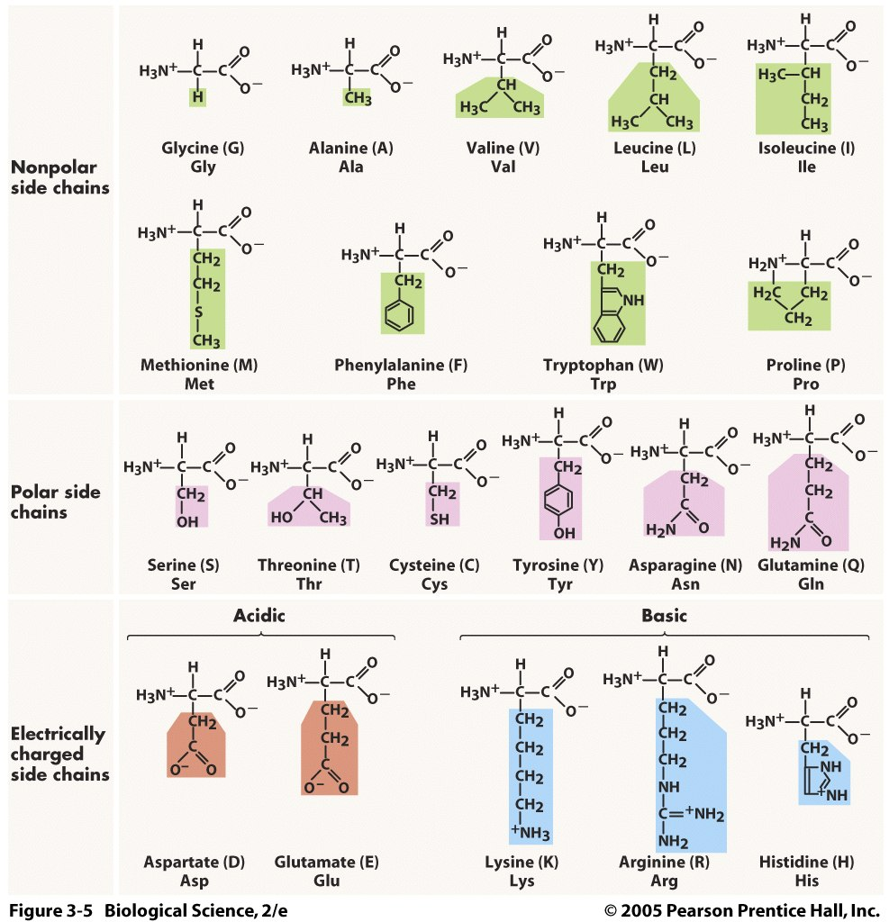](http://www.google.com/url?sa=i&rct=j&q=&esrc=s&frm=1&source=images&cd=&cad=rja&uact=8&ved=0CAcQjRxqFQoTCPr2msiK-ccCFU8RkgodtpAI_w&url=http://healthylifetips.xyz/tag/positive-amino-acids&psig=AFQjCNEGPL3Hh-mQoNjRYGkk_1dPYppj1w&ust=1442407910617672) [](http://www.google.com/url?sa=i&rct=j&q=&esrc=s&frm=1&source=images&cd=&cad=rja&uact=8&ved=0CAcQjRxqFQoTCPr2msiK-ccCFU8RkgodtpAI_w&url=http://healthylifetips.xyz/tag/positive-amino-acids&psig=AFQjCNEGPL3Hh-mQoNjRYGkk_1dPYppj1w&ust=1442407910617672) [](http://www.google.com/url?sa=i&rct=j&q=&esrc=s&frm=1&source=images&cd=&cad=rja&uact=8&ved=0CAcQjRxqFQoTCPr2msiK-ccCFU8RkgodtpAI_w&url=http://healthylifetips.xyz/tag/positive-amino-acids&psig=AFQjCNEGPL3Hh-mQoNjRYGkk_1dPYppj1w&ust=1442407910617672) [](http://www.google.com/url?sa=i&rct=j&q=&esrc=s&frm=1&source=images&cd=&cad=rja&uact=8&ved=0CAcQjRxqFQoTCPr2msiK-ccCFU8RkgodtpAI_w&url=http://healthylifetips.xyz/tag/positive-amino-acids&psig=AFQjCNEGPL3Hh-mQoNjRYGkk_1dPYppj1w&ust=1442407910617672) [](http://www.google.com/url?sa=i&rct=j&q=&esrc=s&frm=1&source=images&cd=&cad=rja&uact=8&ved=0CAcQjRxqFQoTCPr2msiK-ccCFU8RkgodtpAI_w&url=http://healthylifetips.xyz/tag/positive-amino-acids&psig=AFQjCNEGPL3Hh-mQoNjRYGkk_1dPYppj1w&ust=1442407910617672)

[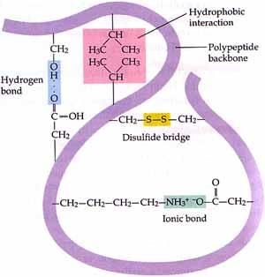](https://www.google.com/url?sa=i&rct=j&q=&esrc=s&frm=1&source=images&cd=&cad=rja&uact=8&ved=0CAcQjRxqFQoTCPLE8aON-ccCFcgFkgodjCUNfw&url=https://www.studyblue.com/notes/note/n/cell-bio-exam-i-mesner/deck/5518279&bvm=bv.102537793,d.aWw&psig=AFQjCNF5rAdXD7OBp56tM1QAlcfBOG2Akg&ust=1442408647131380)